# Soft Shadow UI PRO

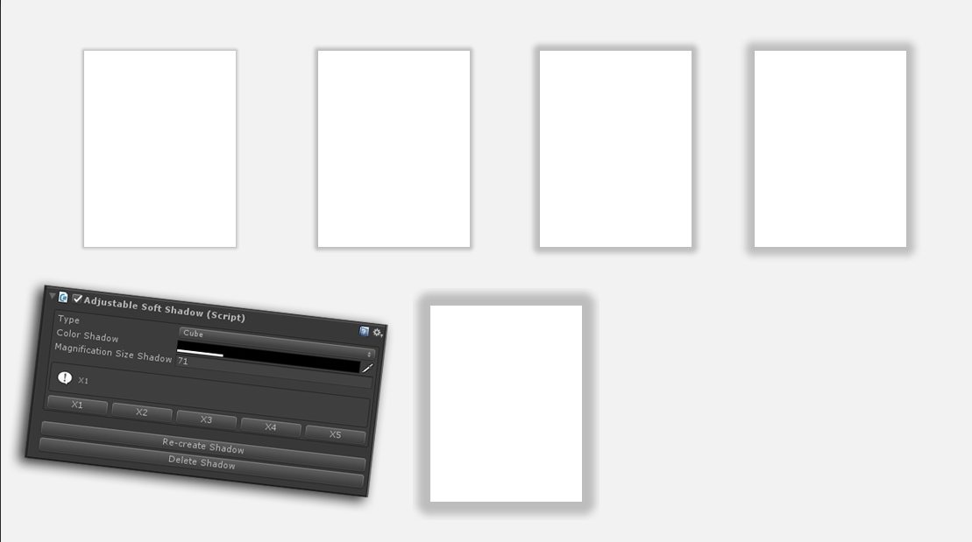

In order to add a soft shadow to the object UI you want to move the script "AdjustableSoftShadow" to this object, then the settings will be described:

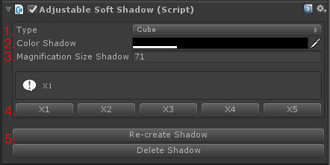

1. Type (Cube, Circle) - сhoose this item depending on which object you want to add a shadow.
2. Color Shadow - сhoose the color and transparency of the shadow.
3. Magnification Size Shadow (Default is 71) - adjust the size of the shadow to the picture.
4. The width of the shadow, there are 5 species, 5 - the widest.
5. Buttons to control the shadow, you can remove the shadow, create a shadow, recreate the shadow.